**Practical 4: Chapter 5 Table & Chapter 6 Form**

**Section A:**

**Lab Exercise (Compulsory)**

Book : Carey, P. 2017. New Perspectives on HTML5 and CSS – Comprehensive. 7th Edition. Cengage Learning.

Page : 489 to 490 (Chapter 5 Table)

Exercise (s): Review Assignments (Tutorial 6)

Page : 422 to 425 (Chapter 5 Table – different design for different device)

Exercise (s): Review Assignments (Tutorial 5)

Page : 571 to 574 (Chapter 6 Form)

Exercise (s): Review Assignments (Tutorial 7)

**Additional Lab Exercise (Optional)**

Book : Carey, P. 2017. New Perspectives on HTML5 and CSS – Comprehensive. 7th Edition. Cengage Learning.

Page : 491 to 492 (Chapter 5 Table)

Exercise (s): Case Problem 1 (Tutorial 6)

Page : 574 to 576(Chapter 6 Form)

Exercise (s): Case Problem 1 (Tutorial 7)

**Section B:**

Question 1

Use HTML code and embedded styles sheet to create the table in Figure 1 with the following specifications:

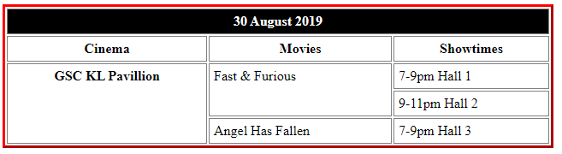

Figure 1

Specifications:

* The table takes up 50% of the display area and create separate borders for table border and cell border.
* Set the table border to to red color , 2-pixel width and ~~dashed~~ solid border style.
* Set cell border to grey colour, 1-pixel width and solid border style.
* Set the space between cell border and cell text to 5 pixels.
* Mark the first two rows and the first column of the table as the table heading cells.
* Insert inline styles into the first row, set the background colour to black and text colour to white.

Answer:

<html>

< head>

<style>

table{

width:”50%”;

}

th{

border:2 px solid red;

border-style: dashed solid;

}

td{

border:1 px solid grey;

border-style: solid;

padding:5px;

}

</style>

<head>

<body>

<table>

<tr>

<th colspan=3 style=”background-color: black; color: white;”>30 August 2019<th>

<tr>

<th>Cinema</th>

<th>Mobie</th>

<th>Showtime</th>

</tr>

<tr>

<th rolspan =3>GSC KL Pavillion</th>

<td rolspan=2>Fast &Furious</td>

<td>7-9pm Hall1</td>

</tr>

<tr>

<td></td>

<td></td>

<td>9-11pm Hall 2</td>

</tr>

<tr>

<td></td>

<td>Angel Has Fallen</td>

<td>7-9pm Hall 3</td>

</tr>

</table>

<html>

Question 2

Use HTML and CSS code to create the table in Figure 2 with the following specifications

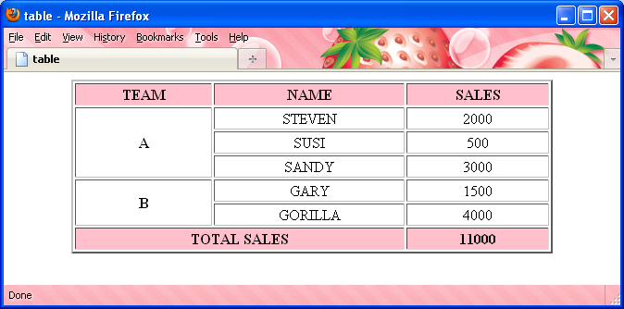

Figure 2

**Specifications:**

* Identify the <thead><tbody> and </tfoot> element.
* Centralized the text within the table.
* Set the table width to 80% of the window.
* Set the table border to 2 pixels.
* Make the first row and last row as table headings.
* Set the background colour of the first row and last row to pink colour.

Answer:

Question 3

Write HTML code to create the form output as shown in Figure 3.

ru

Figure 3

Specifications:

* Make the text "Tarcian Run 2018 Registration Form" as heading 2.
* Name the form as "run2018".
* "Name" field is a textbox.
* "Category" field consists of 3 radio buttons. Give them a group name called category with unique ids each.
* "T-Shirt Size" field is a selection list which consists of 4 options: S, M, L and XL**. [use <datalist> tag instead of the <select> tag to create selection list]**
* "Contact" field is a textbox
* "Email" field is an email type field.
* "Submit Form" is a submit button.
* "Clear Form" is a reset button.

**[Note: Use <br/> instead of the table tag to create the form.]**

Answer: